**Unit-2**

**Chapter-4**

**Lecture 1.6**

Mapped with co2,,34,

confusion matrix

A confusion matrix is a table that is often used to **describe the performance of a classification model** (or "classifier") on a set of test data for which the true values are known. The confusion matrix itself is relatively simple to understand, but the related terminology can be confusing.

I wanted to create a **"quick reference guide" for confusion matrix terminology** because I couldn't find an existing resource that suited my requirements: compact in presentation, using numbers instead of arbitrary variables, and explained both in terms of formulas and sentences.

Let's start with an **example confusion matrix for a binary classifier** (though it can easily be extended to the case of more than two classes):

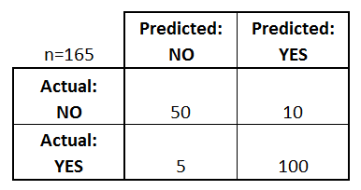

What can we learn from this matrix?

* There are two possible predicted classes: "yes" and "no". If we were predicting the presence of a disease, for example, "yes" would mean they have the disease, and "no" would mean they don't have the disease.
* The classifier made a total of 165 predictions (e.g., 165 patients were being tested for the presence of that disease).
* Out of those 165 cases, the classifier predicted "yes" 110 times, and "no" 55 times.
* In reality, 105 patients in the sample have the disease, and 60 patients do not.

Let's now define the most basic terms, which are whole numbers (not rates):

* **true positives (TP):** These are cases in which we predicted yes (they have the disease), and they do have the disease.
* **true negatives (TN):** We predicted no, and they don't have the disease.
* **false positives (FP):** We predicted yes, but they don't actually have the disease. (Also known as a "Type I error.")
* **false negatives (FN):** We predicted no, but they actually do have the disease. (Also known as a "Type II error.")

I've added these terms to the confusion matrix, and also added the row and column totals:

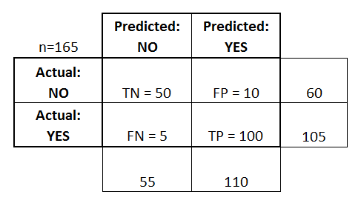

This is a list of rates that are often computed from a confusion matrix for a binary classifier:

* **Accuracy:** Overall, how often is the classifier correct?
* (TP+TN)/total = (100+50)/165 = 0.91
* **Misclassification Rate:** Overall, how often is it wrong?
* (FP+FN)/total = (10+5)/165 = 0.09
* equivalent to 1 minus Accuracy
* also known as "Error Rate"
* **True Positive Rate:** When it's actually yes, how often does it predict yes?
* TP/actual yes = 100/105 = 0.95
* also known as "Sensitivity" or "Recall"
* **False Positive Rate:** When it's actually no, how often does it predict yes?
* FP/actual no = 10/60 = 0.17
* **True Negative Rate:** When it's actually no, how often does it predict no?
* TN/actual no = 50/60 = 0.83
* equivalent to 1 minus False Positive Rate
* also known as "Specificity"
* **Precision:** When it predicts yes, how often is it correct?
* TP/predicted yes = 100/110 = 0.91
* **Prevalence:** How often does the yes condition actually occur in our sample?
* actual yes/total = 105/165 = 0.64

A couple other terms are also worth mentioning:

* **Null Error Rate:** This is how often you would be wrong if you always predicted the majority class. (In our example, the null error rate would be 60/165=0.36 because if you always predicted yes, you would only be wrong for the 60 "no" cases.)
* **Cohen's Kappa:** This is essentially a measure of how well the classifier performed as compared to how well it would have performed simply by chance. In other words, a model will have a high Kappa score if there is a big difference between the accuracy and the null error rate.
* **F Score:** This is a weighted average of the true positive rate (recall) and precision.
* **ROC Curve:** This is a commonly used graph that summarizes the performance of a classifier over all possible thresholds. It is generated by plotting the True Positive Rate (y-axis) against the False Positive Rate (x-axis) as you vary the threshold for assigning observations to a given class.

Books and reading materials.

1. Ethem Alpaydın, Introduction to Machine Learning(Adaptive Computation and Machine Learning), MIT Press, 2004.
2. Mitchell. T, Machine Learning, McGraw Hill, 1997.

**Regression.pptx**